THE CORPORATION OF THE
TOWNSHIP OF LANARK HIGHLANDS

March 13, 2024

Forbes Symon, Senior Planner

Larocque
Consent Application (Lanark County File No. B24-014)

- LOCATION AND DESCRIPTION

The subject property is located at 870 Darling Road and is described as Part Lot 21 Concession 7 in the geographic Township of Lanark, now in the Township of Lanark Highlands. The property is located approximately 12.5 km northeast of the Village of Lanark and 4 km west of Taylor Lake. The property has frontage on Darling Road, being an open and maintained Township Road. The subject property totals approximately 8.97 ha (22.17 ac) in size and is currently occupied by a single-family dwelling and an accessory carport structure (See the keymap in Appendix “A”).

2. PROPOSED CONSENT

The applicant proposes to sever one (1) new lot from the subject property with the following characteristics:

- B24/014 – total lot area of 1.01 ha (2.5 ac) and lot frontage of 75 m (ft) on Darling Road, a township-maintained road. The proposed lot is vacant and is intended to be a residential building lot.

- Retained Lot – total lot area of 7.96 ha (19.66 ac) and 225 m (738 ft) of frontage on Darling Road, a township-maintained road. The lot is occupied by a house and an accessory carport structure.

The subject property is characterized as consisting of mixed forested areas and fairly open fields on the east side of the property. According to GIS mapping, there is also an approximately 2 ac waterbody/non-evaluated/unregulated wetland feature located on the northwest side of the property, behind the existing dwelling. The surrounding land uses consist of similar forested lands.

3. PLANNING ANALYSIS

3.1 Provincial Policy Statement (PPS) 2020

The Provincial Policy Statement provides policy direction on matters of provincial interest related to land use planning that provides for appropriate development while protecting resources of provincial interest, public health and safety, and the quality of the natural and built environment. As per Section 3(5) (a) of the Planning Act, R.S.O. 1990, all planning decisions must be consistent with the PPS. A review of applicable policies must be undertaken, and the application evaluated under the “consistent with” test.

The subject property is located in a Rural Area within the meaning of the PPS.

      - In Rural areas, rural settlement areas shall be the focus of growth and development and their vitality and regeneration shall be promoted.

1.1.5.4 Development that is compatible with the rural landscape and can be sustained by rural service levels should be promoted.

2.1.1 Natural features and areas shall be protected for the long term.

The lot to be severed is to be developed on private services. The residential use of the lands is permitted in a Rural area. As a result of the application, the lot to be severed and the retained lands will remain compatible with the rural landscape and can be sustained by rural service levels. All lands will have frontage on the Township maintained road and will be developed on private services.

3.2 Official Plan

Schedule ‘A’ of the Official Plan designates the subject lands as “Rural Communities”.

3.3.1.3 In order to maintain and protect the landscape and identity of the Rural Communities, it will be important to avoid inefficient land use patterns such as strip or scattered development, to minimize incompatibility between land uses and to minimize adverse environmental impacts.

The surrounding lands consist of mixed rural lands with forested lands and scattered residential lots. The development does not constitute strip development. The severed and retained lots would remain compatible with surrounding land uses and do not appear to present any adverse environmental impacts.

3.3.3.3 Up to three (3) consents, excluding the retained lot, may be granted for a lot or land holding existing as of April 1, 2003.

According to our records, there have been two severances from the landholding since April 1, 2003 (i.e. B18-093 & B18-094), and therefore the proposed severance conforms with the Official Plan. It is worth noting that this will be the last severance permitted from the subject policies under the current Official Plan policies.

3.3.6.2 A hydro-geology study shall be required in support of a lot creation application by consent or plan of subdivision where the proposed lot(s) is/are less than 0.8 hectares (1.9 acres), where related applications would create more than 1 new lot, where the new lot would be adjacent to an existing lot or within 50 metres (164 feet) of an existing lot.

A hydro-geological study is required given the location of the proposed lot.

Application for consent must be evaluated with the policy directives of Section 8.4.2, which provides direction for the division of lands within the Township. The proposed severed and retained lots will conform to the criteria listed in section 8.4.2 provided that the recommended conditions of consent are approved.

Section 8.4.9 of the Official Plan sets out the requirement for all development to meet Minimum Distances Separations (MDS), ensuring future residential development meets the necessary separation from agricultural livestock facilities. According to GIS mapping, there do not appear to be any agricultural buildings located within 500 metres of the subject property. As such, MDS calculations were not included in this analysis.

3.3 Zoning By-law

Under the Township’s Comprehensive Zoning By-law No. 2003-451, the subject property is currently zoned Rural (RU). The RU zone requires a minimum lot area of 1 ha (2.47 ac.) and a minimum lot frontage of 60 m (196.8 ft). The proposed severed lot will be 1.01 ha (2.5 ac.) and will have 75 m (246 ft) of frontage on Darling Road. The retained lands will continue to exceed the requirements of the RU zone.

The proposed severed and retained lots will comply with the zoning provisions of the Rural (RU) zone.

4. COMMENTS

There were no comments or concerns received at the time of the writing of this report.

5. CONCLUSIONS

Based on the foregoing, it is concluded that the proposed consent is consistent with the PPS and conforms to the Township’s Official Plan and Zoning By-Law, provided that the recommended conditions of consent are approved.
Attachments:
Appendix ‘A’: Key Map
Appendix ‘B’: Official Plan Schedule
Appendix ‘C’: Zoning Schedule
Appendix ‘D’: Conditions of Consent
Appendix A
Key Map

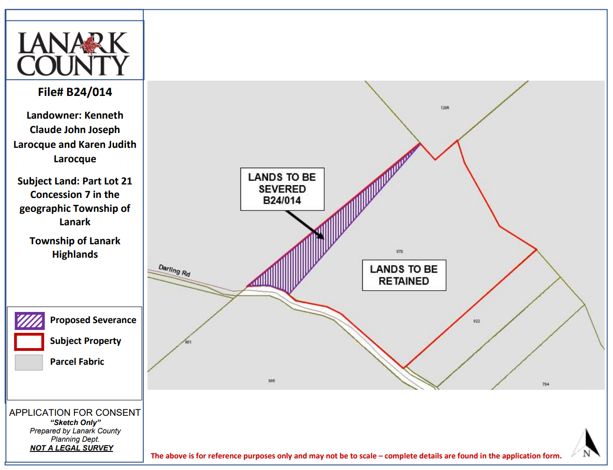

Appendix B
Official Plan Schedule A
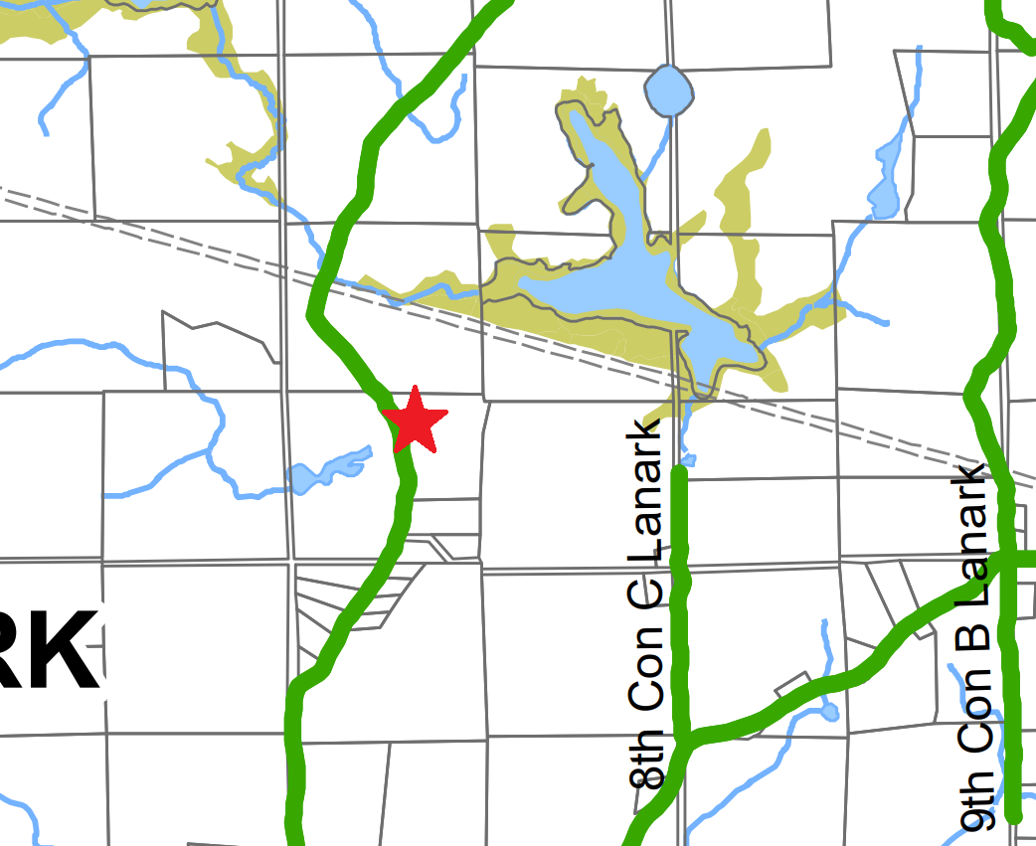
Subject Land – Rural Communities designation

Appendix B
Official Plan Schedule B
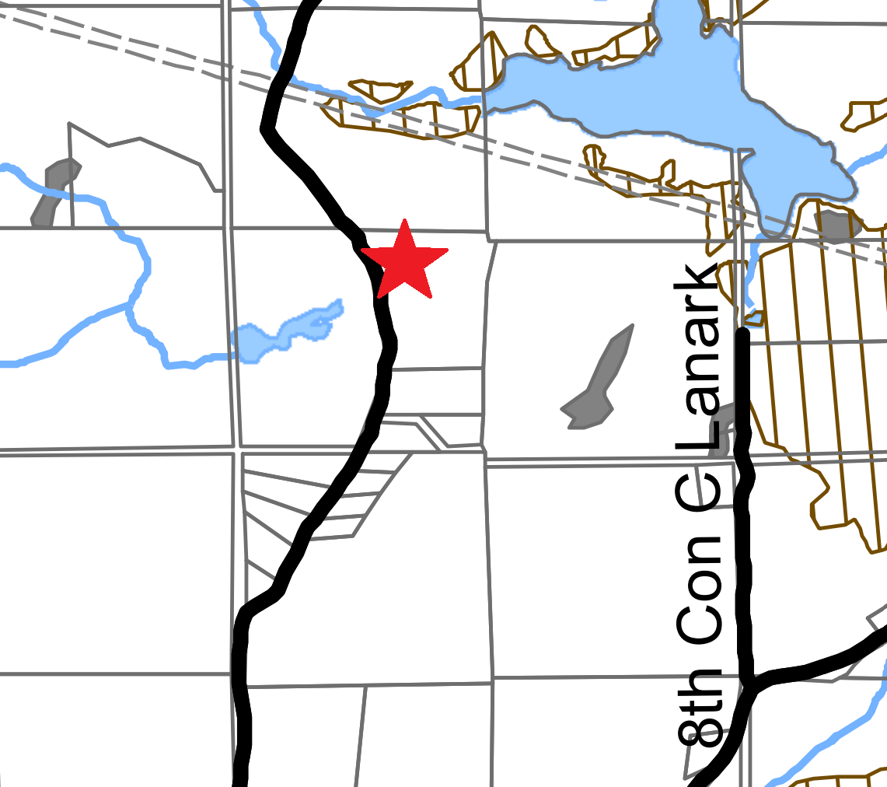

Subject Land

Appendix C
Zoning Schedule
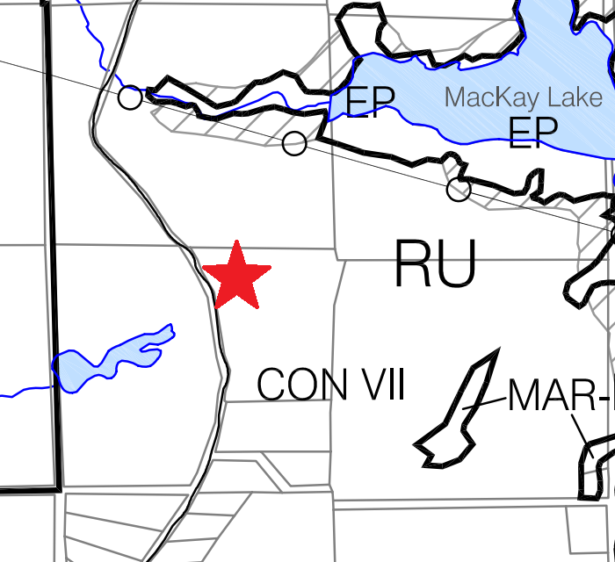
Subject Land: Rural

Appendix D
Conditions of Consent (B24-014)

- That the balance of any outstanding taxes, including penalties and interest, (and any local improvement charges, if applicable) shall be paid to the Township.

- That the applicant provides a digital and paper copy of an acceptable draft reference plan or legal description of the severed lands and the draft deed or Instrument conveying the severed land to the Township for review.

- The applicant shall provide the Township with a digital and paper copy of all deposited reference plans associated with this application.

- Payment shall be made to the Township of $200, representing the amount satisfactory to the Township in accordance with their Cash-in-Lieu of Parklands By-law pursuant to Section 42 of the Planning Act.

- That the applicant shall obtain a Civic Address Number from the Township of Lanark Highlands for the retained lot. The applicant shall consult directly with the Township in this regard.

- That the applicant shall confirm that residential entrance to the severed lot is viable and obtain any necessary entrance permits from the Township.

- That sufficient land be deeded to the Township of Lanark Highlands along the frontage of the severed and/or retained lots to meet the municipality’s road widening requirements, at no cost to the Township (10 m from the centreline of road). Deeds are to be submitted to the municipality for review accompanied by a solicitor’s certificate indicating that the municipality’s title is free and clear of all encumbrances and that the municipality has a good and marketable title. The Township’s Public Works Manager should be consulted prior to commencing a survey to determine the amount of road widening required.

- If required, that the applicant enter into a Development Agreement with the Township of Lanark Highlands, that will be registered on title, to ensure the orderly development of the land.

